RETRIEVAL AUGMENTED GENERATION (RAG)
WITH LANGCHAIN
- Retrieval-Augmented Generation(RAG) is the process of optimizing the output of a large language model(LLM), so it references an authoritative knowledge base outside of its training data sources before generating a response.
- LLM's are trained on vast volumes of data and use billions of parameters to generate original output for tasks like answering questions, translating languages, and completing sentences.
- RAG extends the already powerful capabilities of LLM to specific domains all without the need to retrain the model. It is a cost-effective approach to improving LLM output so it remains relevant, accurate and useful in various contexts.
- Example for RAG: Perplexity

DRAWBACKS OF LLM’s:
- LLM’s hallucinates
- Suppose we want to build a chatbot specific to a company, we need to finetune the LLM and whenever the data changes we need to again finetune the model which is very costly as LLM’s are trained on billion’s of parameters.
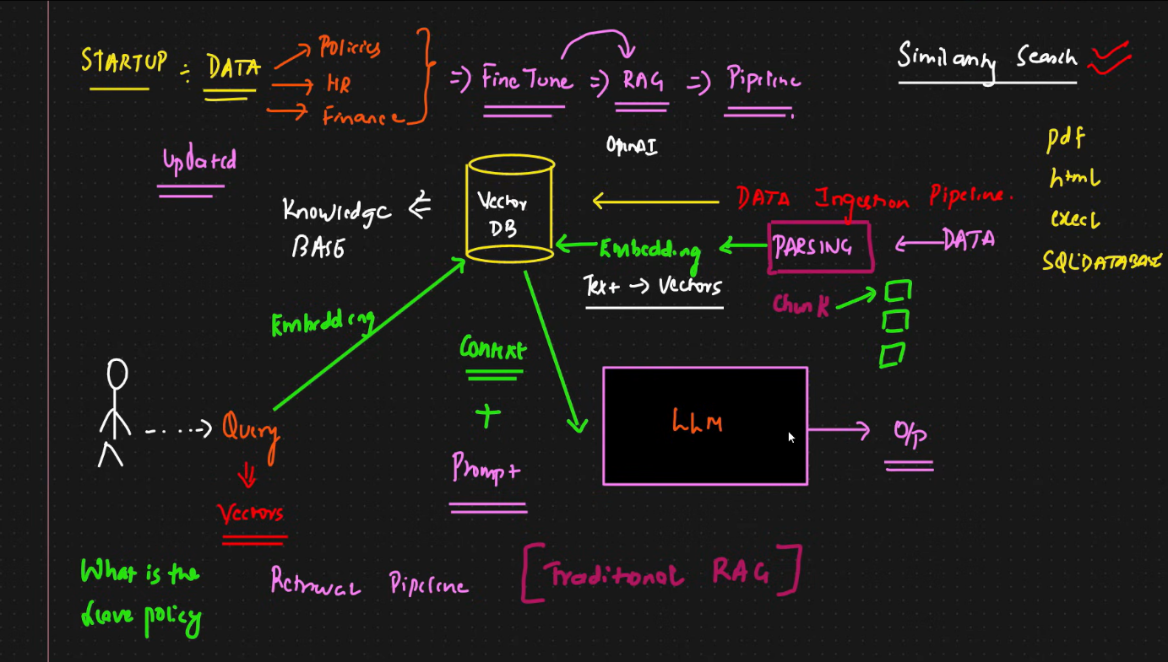
BUILDING BLOCKS OF RAG ARCHITECTURE:
- Document structure
- Complete RAG Pipeline – 1) Data ingestion pipeline and 2) Query retrieval pipeline
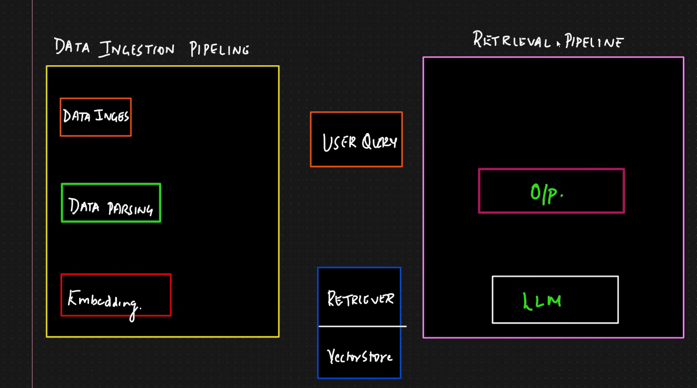
DATA INGESTION PIPELINE:
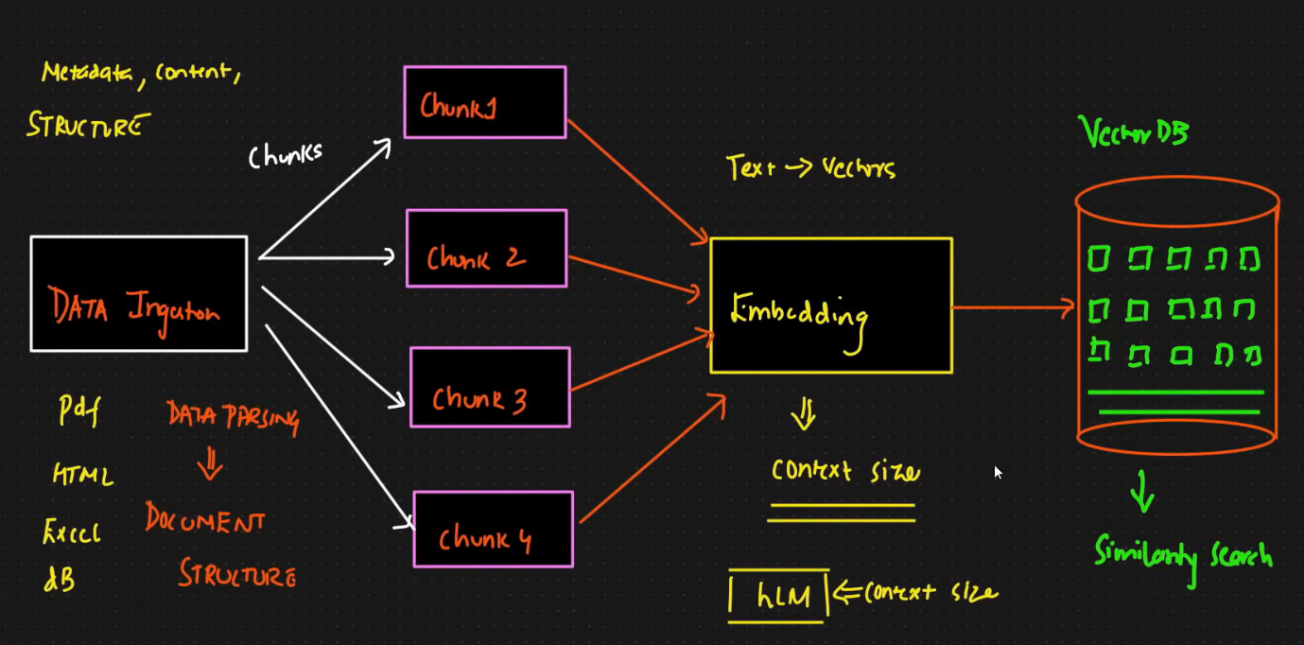
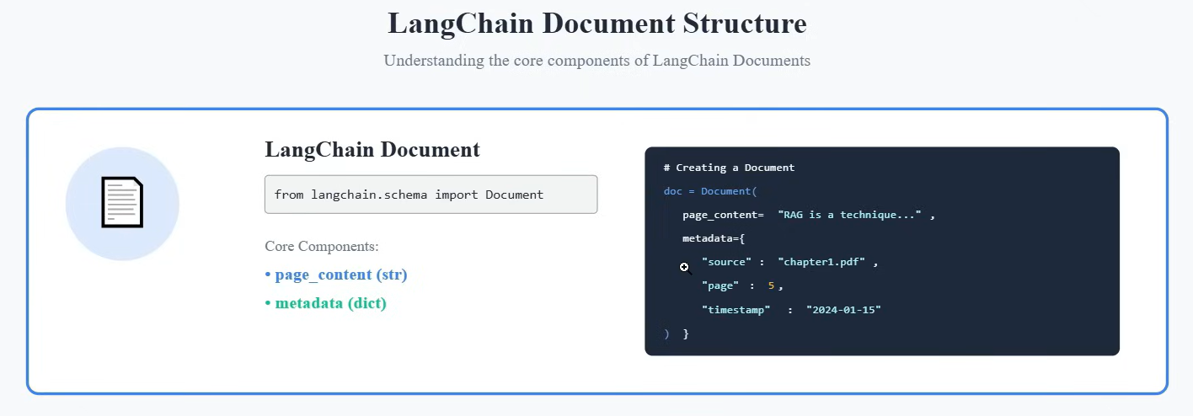
- LangChain document structure is a data structure that saves the information in a format.
- Core components:
Page Content: Contains the information of the page
Meta-data: Contains additional information.
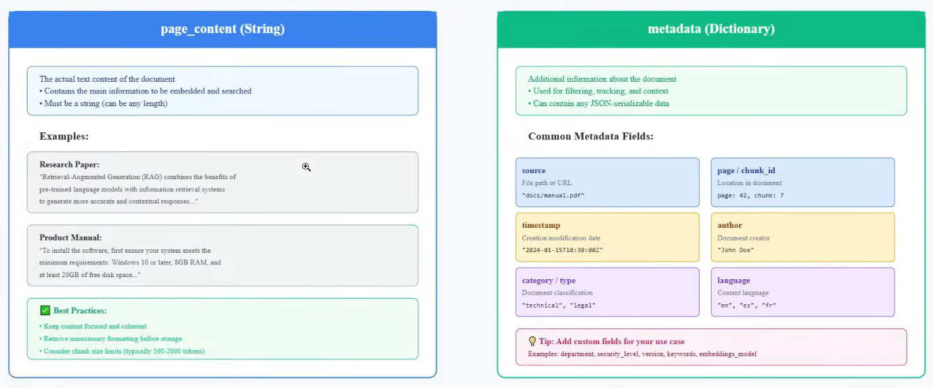
- Document Loaders: Used to load the input data uploaded in the form of HTML,PDF,DOCX,Excel,SQL etc., and outputs it in the document structure.
